Double Dissociation implicit vs explicit memory and nicotine and methylphenidate

# Introduction

* What is procedural learning? What is associative learning?
* Effects of MPH and nicotine, specifically on PL, AL
* What has been done so far?
  + Direct comparison MPH, NIC
    - Kasparbauer 2016
    - Animal studies
  + Enhancement of learning with drugs
    - Also briefly animal findings
  + fMRI studies on PL, AL
* why it is important to investigate effects of drugs on learning
  + performance changes
  + brain changes
  + clinical usage
* Hypotheses
  + How will MPH affect
  + How will NIC affect

# Methods and Materials

## Subjects

The study was approved by the ethics committee of the Department of Psychology at the University of Bonn. Subjects were recruited via advertisements posted on university boards and screened via telephone interview for a first set of inclusion and exclusion criteria. Inclusion criteria were healthy right-handed male non-smokers, free of current physical illness as well as no history of psychiatric disorders. Exclusion criteria were eye-sight or eye movement deficits, lifetime consumption of more than seven cigarettes in their life time, any current prescription or over-the-counter medication, any personal history of head injuries with loss of consciousness, any current Axis I diagnosis and any current or history of psychotic disorders (as assessed with the MINI International Neuropsychiatric Interview; Ackenheil et al, 1999), claustrophobia, bodily shrapnel or other metals, pacemakers and implanted prosthesis. After telephone screening potential candidates attended a medical examination at the University Hospital Bonn. The medical examination served to detect further exclusion criteria, such as poor physical health, signs of neurological impairments, and confirmed other exclusion criteria such as any current medication. Only after the physician’s approval, subjects were invited to take part in the imaging procedure. All subjects provided written, informed consent and were compensated for their time and travel.

## Design and Procedure

A between-subjects, placebo-controlled, double-blind design was applied. Subjects were randomly assigned to one of three treatment groups: 40mg methylphenidate, 7mg nicotine, or placebo.

The administered dosage of 40mg oral methylphenidate has previously been shown to affect BOLD during different cognitive tasks (Costa et al., 2013; Farr et al., 2014; Pauls et al., 2012; Ramaekers et al., 2013; Sripada et al., 2013). The dose is comparable to a therapeutic daily dosage for an adult with ADHD and is expected to block approximately 72% of dopamine transporters (Volkow et al., 1998). Previous studies have shown that oral dosage of methylphenidate achieves peak plasma level after about 60 minutes (Swanson and Volkow, 2002; Volkow, 1995; Volkow et al., 2001), therefore subjects were scanned one hour after capsule administration. The identical looking placebo capsule contained lactose.

A 7mg transdermal nicotine patch (NiQuitin Clear 7mg, GlaxoSmithKline, Germany) was applied to the upper back by a research assistant who was not involved in the scanning procedure. This method has led to reliable effects on eye movements in previous studies (Petrovsky et al., 2012; Schmechtig et al., 2013), with nicotine reaching peak plasma level three hours after application (a nicotine plateau level is achieved after 2 to 4 h after application according to the Summary of Product Characteristics of NiQuitin Clear). The placebo patch contained capsaicin to elicit itchiness similar to the nicotine patch (Rheumaplast, 4.8mg, Hansaplast, Germany). Placebo patches were cut to the approximate size of the nicotine patches (3x2cm).

Subjects were asked to abstain from alcohol the day before the scanning appointment and to arrive at the facilities well rested. On the day of assessment, subjects were administered the Edinburgh Handedness Inventory (Oldfield, 1971) and a measure of verbal intelligence (Mehrfachwahl-Wortschatz-Intelligenztest, Version B, MWT-B; Lehrl, 1995; maximum score: 37). Each subject received a patch and two hours later a capsule. They were administered (a) a nicotine patch and a placebo capsule, (b) a placebo patch and a methylphenidate capsule or (c) a placebo patch and a placebo capsule. One hour after capsule administration, the imaging procedure started. During the waiting period, subjects remained at in the MRI facilities and stayed abstinent from food and beverages except water. Additionally, subjective mental state was assessed with visual analogue rating scales (Bond & Lader 1974) immediately before patch administration (T1) and before scanning (T2). From these scales three subjective measures for each participant and time point were obtained: alertness, contentedness and calmness (Bond & Lader 1974), where higher scores indicated less alert, contented and calm.

# Behavioural Tasks and Analysis

### Stimulus Presentation

Both paradigms were presented on a 32-inch MRI compatible TFT LCD monitor (NordicNeuroLab, Bergen, Norway; resolution: 1024x768 pixel, refresh rate: 120Hz) standing at the rear end of the magnet bore via a first-surface reflection mirror mounted on the head coil. The distance from the eye to the monitor was approximately 172cm. The order of tasks was counterbalanced within treatment groups.

### Procedural Motor Learning Task

All subjects performed a 10-min sequence learning task in a blocked periodic AB design; this was a modified version of the task used in our previous pharmacological study (Kumari et al., 1997). The task consisted of two 30-s alternating conditions: blocks of random trials (RAN, control condition) and blocks of pattern trials (PAT, experimental condition). In total, there were four different sequences randomly interspersed in the experimental condition. The same sequence maximally occurred once in a row, then another one of the three sequences started. A sequence consisted of five trials with the following consecutive target movements: horizontal, vertical, diagonal, horizontal, random. Subjects were not told of the existence of specific rules governing the target movements during the pattern blocks, and the beginning of random and pattern blocks was not marked in any way. Subjects were asked to follow each target movement with their right hand as fast as possible using an MR compatible key pad with four keys, each key corresponding to one of the four quadrants. The movement of the target was initiated by the subjects’ touching the target key. Reaction times were recorded on-line.

Reaction time data were analysed by a three-way substance group (placebo, methylphenidate, nicotine), trial type (random, block) and block number (1-10 for random and pattern blocks) analysis of variance. A possible violation of the sphericity assumption was taken into account through the Greenhouse-Geisser correction.

### Object-Location Association Task

We used a spatial source memory task used previously by Cansino et al. (2002) and Kukolja et al. (2008, 2009). Briefly, the experiment consisted of an encoding and a retrieval session. During both encoding and retrieval, fMRI measurements took place. Stimuli to be encoded and retrieved were black and white photographs of natural and artificial objects. The baseline display consisted of a green cross, which divided the screen into four quadrants. A small red cross was superimposed in the middle and served as fixation point. During the encoding session, 96 stimuli were selected for each subject from a pool of 144 stimuli. The stimuli appeared randomly for 2000ms in one of the four quadrants of the screen and were followed by an interstimulus interval of 1450 ms. Subjects were told to memorize each item and the position where it appeared. To ensure sufficient processing and recognition of the stimuli, subjects had to indicate with the index and middle finger of their right-hand whether the object was “natural,” e.g., an animal or a vegetable, or whether it was “artificial,” e.g., a tool or an instrument. During the retrieval run, all 144 stimuli were presented randomly at the center of the screen. Thus, in addition to 96 objects previously shown items (old items), 48 new stimuli (new items) were interspersed. Stimuli were presented for 1500 ms, followed by a 2650ms interstimulus interval. Responses were recorded with a five-button pad. Response combined old-versus-new recognition judgment and object-location judgment. For new items the correct response was a button press with the thumb. For old stimuli the index to little finger mapped the four possible locations. Subjects were instructed to make a guess regarding the position of the object if they were not sure about the position.

The durations of the encoding and retrieval sessions were 9.1 and 14.8 min, respectively. There was 10 min pause between the sessions during which subjects maintained their position in the scanner. In both sessions, 1/3 of the stimuli were null events in which merely the baseline picture was shown. This effectively resulted in variable stimulus-onset asynchronies and allowed a comparison of the blood oxygen level dependent (BOLD) signal of the event types of interest with a no-stimulus baseline.

Accuracy and reaction times of old versus new item judgments and correct versus incorrect spatial judgments were analysed. Additionally, a signal detection analysis was applied to investigate treatment specific differences in old versus new judgments (for details see Kukolja et al., 2009). In the encoding phase items were divided in (1) items with correct spatial association in retrieval phase (CorSCE) and (2) items with false spatial association in the retrieval phase (FalSCE). Accordingly, in the retrieval phase, items were categorized as old items with correct (CorSCR) or false spatial judgment (FalSCR) or new items (New).

ANALYSIS??

## Neuroimaging Data and Analysis

### Image Acquisition

Imaging data were acquired via a 3T Siemens Trio Scanner (Siemens, Erlangen, Germany) at the Life &and Brain Centre, Bonn. Subjects wore earplugs and foam padding was used to reduce head motion. During the experimental tasks functional images of the brain depicting the blood-oxygen-level-dependent (BOLD) response were obtained using a T2*-weighted gradient-echo planar image (EPI) sequence (TR=2500ms; TE=30ms; flip angle=90°). Each image volume consisted of 37 slices obtained in sequential order, each 3mm thick with an interslice gap of 0.3mm and an in-plane resolution of 2x2mm2 (FOV = 192×192mm2, matrix = 96×96). A standard twelve-channel head coil was used for radio- reception and transmission. Slices were oriented to the intercommissural plane (AC-PC line). Subsequently, a high-resolution structural image was acquired using 3D MRI sequences for anatomical co-registration and normalization (TR = 1660ms, TE = 2.54ms, flip angle = 9°, matrix = 320×320, FOV = 256×256mm2, slice thickness = 0.8mm).

### Preprocessing

fMRI data were pre-processed and analysed using Statistical Parametric Mapping 12 (SPM12; http://www.fil.ion.ucl.ac.uk/spm/software/spm12/) running in MATLAB R2015b (The MathWorks, Inc.).

First, movement correction was applied by realigning each participant’s functional images to their mean using a least squares approach and a six parameter rigid body transformation (x, y, z, pitch, roll, yaw). Unwarping was performed by means of SPM12 default settings. Second, T1-weighted images were segmented into white matter, grey matter and cerebrospinal fluid using mutual information and a priori tissue probability maps. The T1-weighted high-resolution scan was coregistered to the mean T2*-weighted image of the preceding realign and unwarp process by maximising normalised mutual information using a rigid body transformation. The resulting normalising parameters were used to project the anatomical and functional images via non-linear transformations on the Montreal Neurological Institute (MNI) template with a voxel size of 2x2x2mm. Finally, the normalized images were smoothed using an 8mm full-width at half maximum (FWHM) Gaussian kernel (Mikl et al. 2008). Furthermore, the six movement parameters were used to calculate the total displacement (TD) parameter which contains information about the overall movement for each participant. This was done using the Motion Fingerprint Toolbox (Wilke 2012) with standard cortical distance (davg) of 65mm. Participants were excluded if TD exceeded voxel size (TD>3mm; Wilke 2012).

Post hoc t-tests were used to explore the direction of the observed effects and were focused on clusters of the prior F-test that survived correction for multiple comparison. For all analyses, the statistical height-threshold was set to p<0.05 family wise error (FWE) corrected at peak voxel threshold.

Anatomical locations were determined using the Automated Anatomical Labeling (AAL) atlas (Tzourio-Mazoyer et al. 2002) of the WFU PickAtlas toolbox (http://www.ansir.wfubmc.edu/) running in Matlab R2015b. Mean local signal change of clusters of interest was extracted using MarsBaR (MarsBaR region of interest toolbox for SPM).

In order to explore associations between drug effects at levels of behaviour and BOLD, Pearson correlations were carried out between change scores of BOLD in clusters that showed significant drug effects and change scores of behavioural variables.

### Statistical Analyses

#### Object Location Association Task

We defined four onset regressors specifying the onset times of encoding- and retrieval- related trials in which either correct or incorrect behavioural responses were recorded. Analogous to previous fMRI studies of object-location learning (28–30), our analysis focused on stimuli that were correctly recognized as “old.” Depending on whether the object-location judgment for these stimuli succeeded or failed, encoding (E) and retrieval (R) trials were classified as either correct (EC, RC) or false (EF, RF). The hemodynamic response to each of these four different event types (subsequently referred to as accuracy) was modeled using a canonical HRF and its first derivative, including the six head movement parameters as confounds. First-level linear baseline contrasts were calculated comparing each onset regressor with the implicit baseline. These contrasts were then taken to the second level, where they were subjected to a full-factorial model with the factor accuracy (CorSCE/CorSCR vs. FalSCE/FalSCR) and substance (placebo, methylphenidate, nicotine). T-test analyses were used to constrain the direction of the observed effects. Unequal variances were compensated for by nonsphericity correction.

#### Procedural Motor Learning Task

First-level analysis was conducted using a general linear model (GLM), based on a 30s boxcar function convolved with a canonical hemodynamic response-function (hrf). Onset of pattern blocks were modelled as regressors, random blocks served as implicit baseline. Six motion regressors from the realignment procedure were entered as covariates of no interest.

First-level contrast BlockxTime were subjected to a between-subject ANOVA with the factor substance group. T-test analyses were used to constrain the direction of the observed effects. Unequal variances were compensated for by nonsphericity correction.

# Results

### Subjects

Seventy-five participants were enrolled into the study, of whom one did not complete all fMRI sessions due to nausea and two due to technical issues. Two participants were excluded due to excessive motion (TD >3 mm). Characteristics of the final sample (N=71) are in Table 1.

|  |  |  |  |  |  |  |
| --- | --- | --- | --- | --- | --- | --- |
|  | Nicotine | | Methylphenidate | | Placebo | |
| N | 24 |  | 22 |  | 25 |  |
| Age (years) | 24 | ±3,58 | 24,86 | ±3,75 | 25,56 | ±3,87 |
| Height (cm) | 184,63 | ±5,44 | 181,64 | ±6,11 | 185 | ±5,71 |
| Weight (kg) | 82,38 | ±8,96 | 79,64 | ±7,82 | 79,96 | ±10,91 |
| Body-Mass-Index (kg/m2) | 24,13 | ±1,95 | 24,18 | ±2,48 | 23,37 | ±3 |
| MWT_B Score (total of 40) | 30,29 | ±2,01 | 30,36 | ±2,54 | 31 | ±2,78 |
| Education (years) | 16,48 | ±2,18 | 16,78 | ±3,05 | 17,42 | ±3,22 |
| D2 Score (total) | 546,04 | ±64,97 | 555,33 | ±70,94 | 528,96 | ±62,88 |
| **Object Location Association Task** |  | |  |  |  |  |
| Encoding:Accuracy (%) | 97,4 | ±2,42 | 97,59 | ±3,17 | 97,21 | ±2,7 |
| Retrieval: CorSCR (%) | 40,36 | ±12,55 | 46,54 | ±12,83 | 41,29 | ±16,35 |
| Retrieval: CorSCR+FalSCR (%) | 75,69 | ±8,8 | 79,17 | ±8,25 | 71,33 | ±10,1 |
| D-Prime | 1,92 | ±0,6 | 2,09 | ±0,47 | 1,68 | ±0,61 |
| **Procedural Motor Learning Task** |  | |  |  |  |  |
| Number of Error Trials | 13,04 | ±7,27 | 16,18 | ±12,44 | 16 | ±10,85 |
| RT Pattern Blocks (ms) | 493,42 | ±50,39 | 521,37 | ±56,48 | 510,22 | ±51,57 |
| RT Random Blocks (ms) | 494,82 | ±48,7 | 525,27 | ±52,56 | 513,99 | ±49,71 |
| **Subjective Ratings** |  |  | |  |  |  |
| Alertness T1 | 2,92 | ±0,65 | 2,94 | ±0,66 | 3,27 | ±0,43 |
| Alertness T2 | 3,02 | ±0,57 | 2,85 | ±0,7 | 3,24 | ±0,58 |
| Contentedness T1 | 2,91 | ±0,68 | 2,7 | ±0,9 | 3,06 | ±0,5 |
| Contentedness T2 | 2,85 | ±0,73 | 2,67 | ±0,82 | 2,93 | ±0,58 |
| Calmness T1 | 2,99 | ±0,74 | 2,75 | ±0,93 | 3,08 | ±0,69 |
| Calmness T2 | 2,97 | ±0,77 | 2,91 | ±0,95 | 2,93 | ±1 |

|  |  |  |  |  |  |  |
| --- | --- | --- | --- | --- | --- | --- |
|  | Nicotine | | Methylphenidate | | Placebo | |
| N | 16 |  | 19 |  | 18 |  |
| Age (years) | 24 | ±4,02 | 24,89 | ±3,67 | 25,22 | ±3,77 |
| Height (cm) | 184,31 | ±5,82 | 182,11 | ±5,92 | 185,06 | ±6,01 |
| Weight (kg) | 80,56 | ±8,62 | 79,95 | ±7,85 | 77,94 | ±10,69 |
| Body-Mass-Index (kg/m2) | 23,67 | ±1,71 | 24,16 | ±2,59 | 22,79 | ±3,14 |
| MWT_B Score (total of 40) | 31 | ±1,9 | 30,47 | ±2,67 | 31,83 | ±2,28 |
| Education (years) | 16,56 | ±2,62 | 16,62 | ±2,94 | 16,78 | ±2,67 |
| D2 Score (total) | 566,81 | ±49,72 | 566,56 | ±60,72 | 520,83 | ±56,45 |
| **Object Location Association Task** |  | |  |  |  |  |
| Encoding:Accuracy (%) | 98,11 | ±1,79 | 97,31 | ±3,34 | 97,11 | ±2,8 |
| Retrieval: CorSCR (%) | 45,83 | ±10,34 | 48,63 | ±12,58 | 42,13 | ±9,47 |
| Retrieval: CorSCR+FalSCR (%) | 77,54 | ±7,51 | 79,11 | ±8,75 | 72,16 | ±7,98 |
| D-Prime | 2,15 | ±0,55 | 2,13 | ±0,48 | 1,66 | ±0,52 |
| **Procedural Motor Learning Task** |  | |  |  |  |  |
| Number of Error Trials | 12,75 | ±7,99 | 16,63 | ±13,08 | 17,28 | ±10,03 |
| RT Pattern Blocks (ms) | 492,1 | ±54,17 | 508,77 | ±45,23 | 513,12 | ±54 |
| RT Random Blocks (ms) | 492,86 | ±52,24 | 513,93 | ±42,8 | 517,53 | ±51,18 |
| **Subjective Ratings** |  |  | |  |  |  |
| Alertness T1 | 2,9 | ±0,64 | 2,93 | ±0,71 | 3,33 | ±0,36 |
| Alertness T2 | 3,07 | ±0,43 | 2,89 | ±0,74 | 3,34 | ±0,49 |
| Contentedness T1 | 3,02 | ±0,57 | 2,73 | ±0,97 | 3,2 | ±0,4 |
| Contentedness T2 | 2,96 | ±0,55 | 2,67 | ±0,87 | 3,08 | ±0,55 |
| Calmness T1 | 3,02 | ±0,74 | 2,89 | ±0,93 | 3,22 | ±0,51 |
| Calmness T2 | 3,09 | ±0,64 | 2,81 | ±0,98 | 3,09 | ±0,71 |



*Note*. Data are presented in means ± standard deviation unless stated otherwise.

## Behavioural Results

### Procedural Motor Learning Task

Reaction time data were analysed by a three-way substance group (placebo, methylphenidate, nicotine), trial type (random, pattern) and block number (1-10 for random and pattern blocks) analysis of variance. Mean reaction times were checked for assumption of normality with Kolmogorov-Smirnov (KS) test with Lilliefors significance correction and a Shapiro–Wilk (SW) test. There was no significant deviation of normality in distribution of data. ~~There was a significant main effect of trial type (~~*~~F~~~~1~~* ~~= 9.766,~~ *~~p = .~~*~~003, partial = .158) and a main effect of block number (~~*~~F~~~~4.239~~* ~~=~~~~13.941,~~ *~~p~~* ~~< .001; partial = .211).~~ There was a significant interaction between trial type and block for mean reaction times (*F6.983* = 9.286, *p* < .001, partial = .12). Simple effects of trial type per block are summarized in Table 2. Further, there was a significant main effect of block for the standard deviation of the reaction times (*F*6.552 = 20.643, *p < .*001, partial = .233) and the coefficient of variation (*F*6.605 = 26.9, *p < .*001, partial = .283). Specifically, the standard deviation and the coefficient of variation, increased as the experiment progressed.

**Table 2**

*Effect of Trial Type Per Block*

|  |  |  |  |
| --- | --- | --- | --- |
| Block | *F1,68* | *p* | Partial η2 |
|
| 1 | 40.574 | < .001 | .374 |
| 2 | 1.009 | .319 | .015 |
| 3 | 4.621 | .035 | .064 |
| 4 | 9.205 | .003 | .119 |
| 5 | 1.782 | .186 | .026 |
| 6 | 5.854 | .018 | .079 |
| 7 | 4.626 | .035 | .064 |
| 8 | 4.306 | .042 | .06 |
| 9 | 2.876 | .094 | .041 |
| 10 | 3.425 | .069 | .048 |

*Note*. F-statistic with degrees of freedom, corresponding significance and effect size for effects of mean reaction time are reported for each block separately.  
*sig. at α = .05.

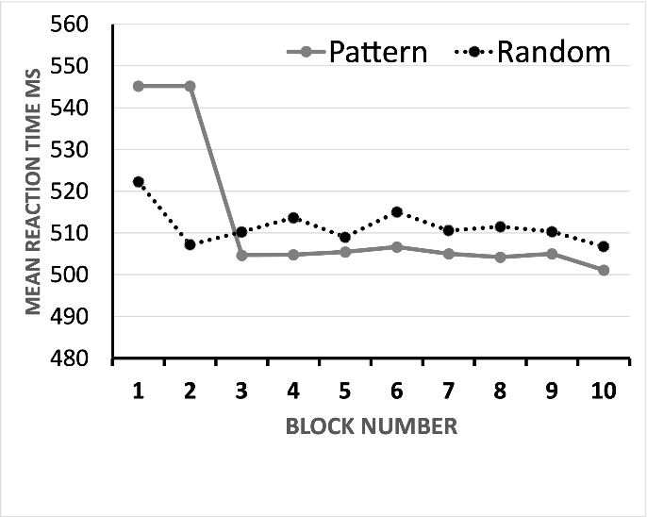

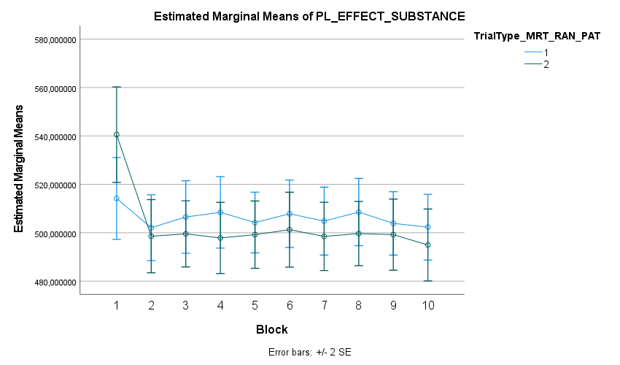

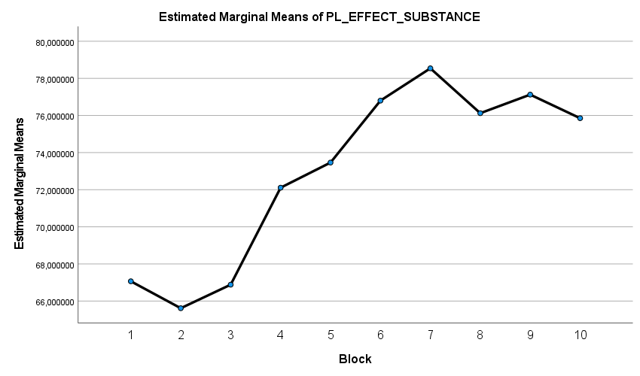SD

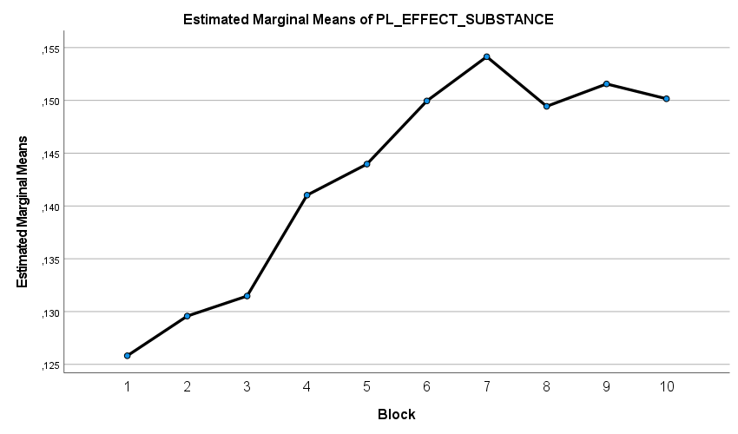CV

### Object-Location Association Task

To exclude the possibility of guessing the spatial context during retrieval, a χ2-test was performed. The expected proportion at chance level for the correct or one of the false quadrants are 25% and 75%, respectively (*df* = 1, *α* = .05). Subjects that did not pass the corresponding criterion (χ2 > 3.841) were excluded from analysis. Thus, 19 subjects were disregarded for the analysis. ~~Additionally, a sufficient number (~~*~~n~~* ~~≥ 12) of false trials in both encoding and retrieval session was required for the fMRI analysis. Based on this criterion, 2 further subjects were excluded.~~ In total, 55 subjects were analysed hereafter (for details, see Table X).

## Neuroimaging Results

|  |  |  |  |  |  |  |  |  |  |
| --- | --- | --- | --- | --- | --- | --- | --- | --- | --- |
|  | Region | Side | x | y | z | Z | F | P | Cluster Size |
| Main Effect Substance | |  | - | - | - | - |  | n.a. |  |
| Main Effect Task | |  |  |  |  |  |  |  |  |
| Inferior Occipital Gyrus | | Left | -22 | -96 | -4 | 6.93 | 30.20 | <0.001 | 302 |
| Inferior Occipital Gyrus | | Right | 30 | -96 | 2 | 6.22 | 23.07 | <0.001 | 140 |
| Superior Temporal Gyrus | | Right | 52 | 0 | -12 | 5.28 | 16.00 | <0.005 | 66 |
|  |  |  |  |  |  |  |  |  |  |
| Legend:MNI Coordinates. | | | | | | | | | |

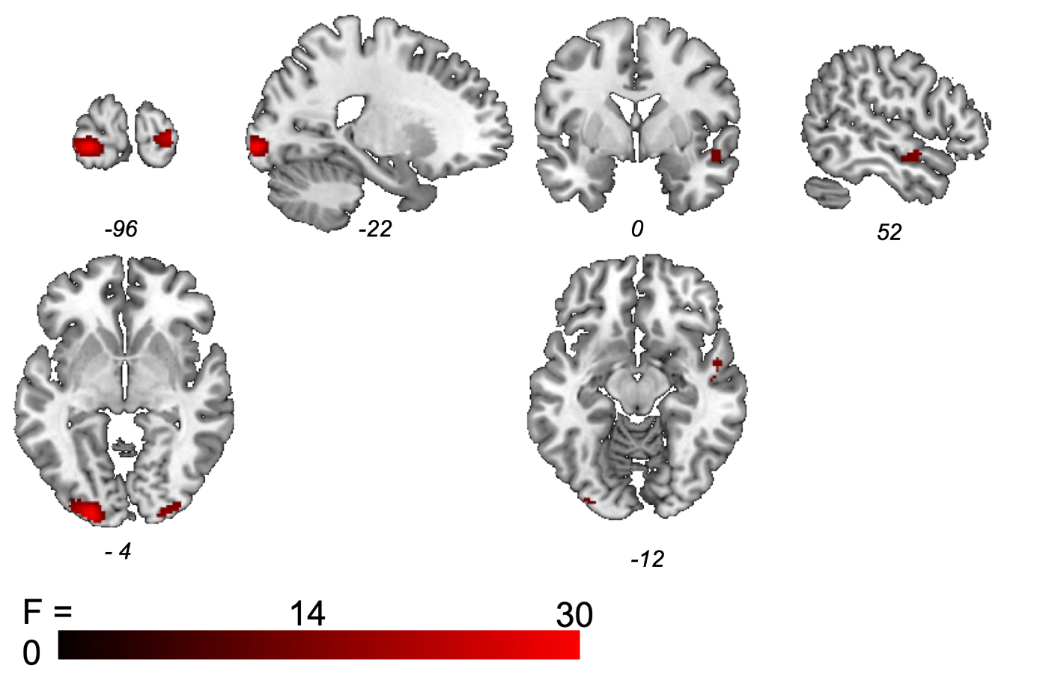

Figure 1 Main Effect of Task Procedural Motor Learning Task

*Object Location Task*

Accuracy and reaction times of old versus new item judgments and correct versus incorrect spatial judgments are listed in Table 1.

|  |  |  |  |  |  |
| --- | --- | --- | --- | --- | --- |
|  | Nicotine | Methylphenidate | Placebo | F(2,67) | p |
| Encoding: Accuracy (%) | 97.42+-2.47 | 97.59+-3.17 | 97.21+-2.70 | 0.108 | 0.898 |
| Retrieval: CorSCR (%) | 39.99+-12.69 | 46.54+-12.83 | 41.29+-16.35 | 1.351 | 0.26 |
| Retrieval: CorSCR + FalSCR (%) | 75.91 +-8.93 | 79.17+-8.25 | 71.33+-10.10 | 4.346 | 0.017 |
| P values reflect the results of between-subject ANOVAs . CorSCR represents percentage of items correctly recognized as previously seen and associated with a correct spatial context judgment. CorSCR + FalsSCR represent percentage of items correctly recognized as previously seen irrespective of the spatial context judgment (item memory). | | | | |

Additionally a signal detection analysis was applied to investigate treatment specific differences in old versus new judgments (for details see Kukolja et al., 2009). In the encoding phase items were divided in (1) items with correct spatial association in retrieval phase (CorSCE) and (2) items with false spatial association in the retrieval phase (FalSCE). Accordingly, in the retrieval phase, items were categorized as old items with correct (CorSCR) or false spatial judgment (FalSCR) or new items (New).

ANALYSIS??